The 3D Approach To Finding Nutritional Balance

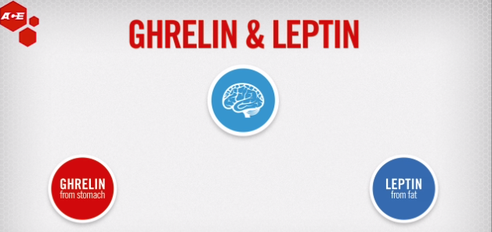
- Increased ghrelin in overweight and obese.
- Make changes: activity; nutrition; behavior. Make small but important changes.
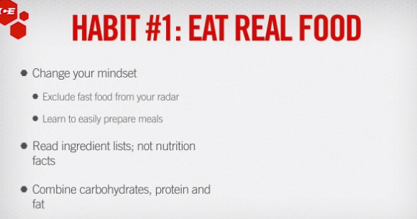
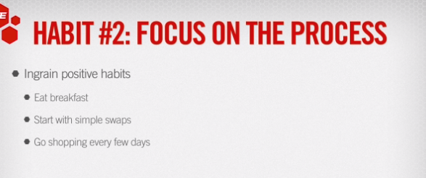
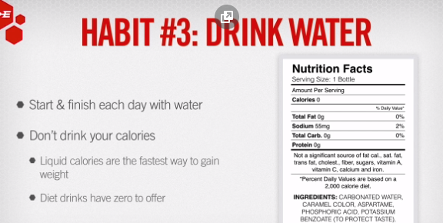
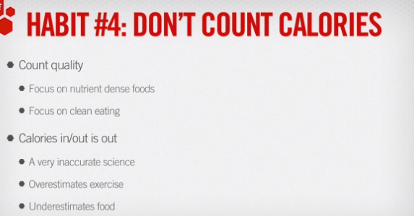
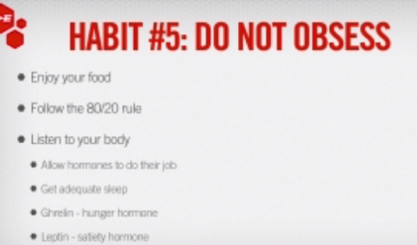
Why did you eat that for breakfast? Why eat at that time?
80/20 course of week 80% good food, 20% other—fast food, ETOH, dessert. Sustainability. Diet plan should be progressive like an exercise plan.
